**SPRINT 4**

**HAZARDOUS AREA MONITORING IN INDUSTRIAL POWER PLANT USING IOT**

**TEAM ID:** PNT2022TMID41953

**Task:**

A mobile application for monitoring the Environment parameters around the region of an industry has been developed using MIT App Inventor.

**Screens Information:**

1. **Screen – 1:** It is the entry screen of the mobile application and will be displayed only for 2000 milli-seconds.
2. **Screen – 2:** It is the login page of the application. Each user has their own user id and password, which is known only to them. After validating the credential, the user can access the data captured by the placed device.
3. **Screen – 3:** Environmental parameters in the area of the industry like temperature is obtained via sensors and is sent to the mobile device.

SCREEN 1:

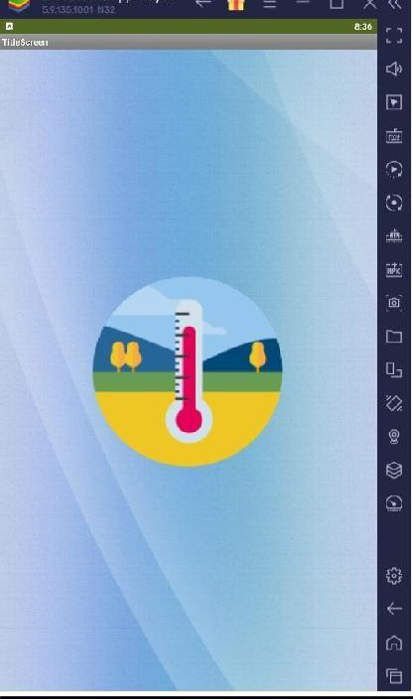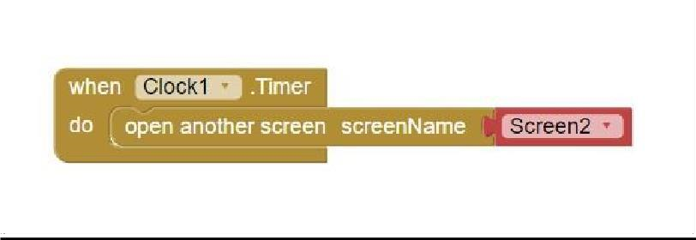

SCREEN 2:

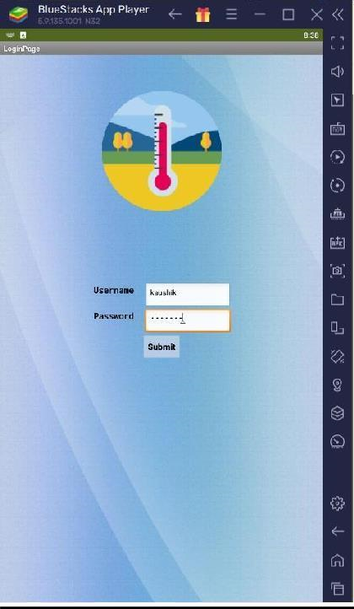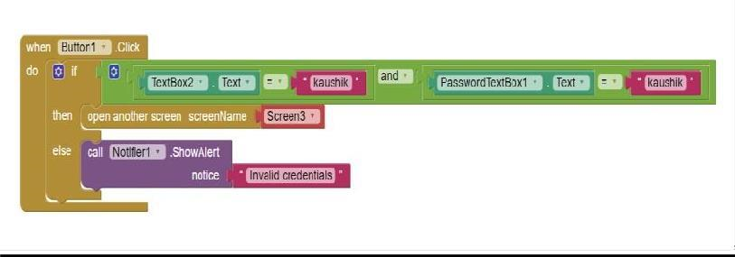

*Case 1 (When the temperature is within limit):*

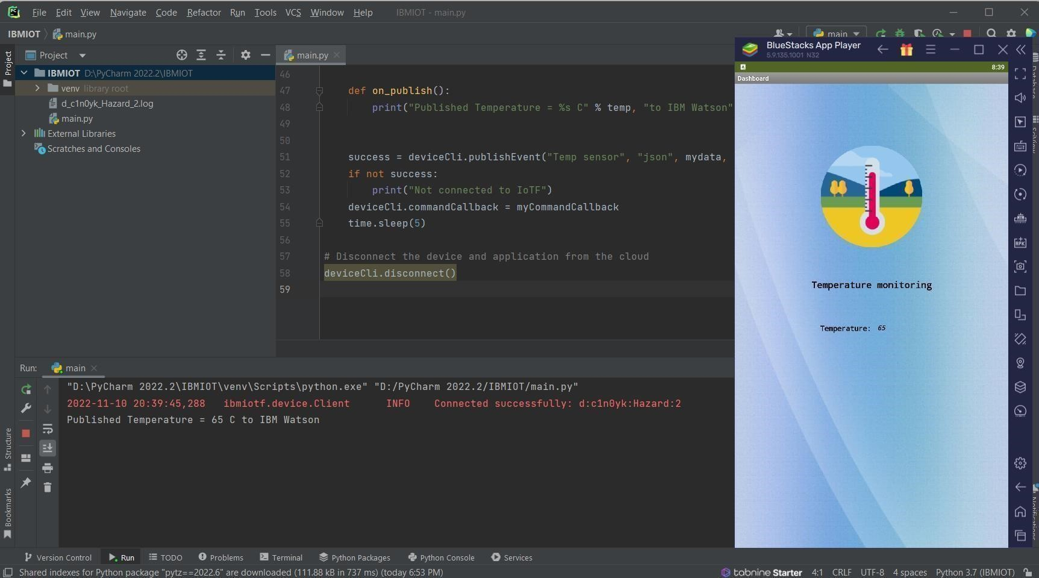

*Case 2 (When temperature exceeds normal (95 C) value):*

